Trade of Metal Fabrication
Module 1: | Basic Fabrication
Unit 13: | Riveted Lap Joint
 | Phase 2

Table of Contents
List of Figures 5
List of Tables 5
Document Release History 6
Module 1 – Basic Fabrication 7
Unit 13 – Riveted Lap Joint 7
Learning Outcome: 7
Key Learning Points: 7
Training Resources: 7
Key Learning Points Code: 7
Making Sharp Edges Safe 8
Rivets 9
Riveting 9
Pop Riveting Guns 10
Hand “Pop” Gun 10
Lazy Tongs 10
Type of Pop Rivets 10
Clamping and Fixed Stops 11
Clamping of Work 11
Clamps 11
Fixed Stops 11
Never 11
Always 11
Holding the Work for Drilling 12
The Machine Vice 12
Clamping of Work 12
Use of Vee Blocks 12
Use of Angle Plate 12
Always 12
Never 12
Edge Distance/Pitch 13
Working Clearance 14
Applications – Types of Rivet and Rivet Head 14
Applications – Pop Riveting 16
Break-Head Type 17
Break-Stem Type 17
Rivet Spacing 21
Defects in Riveted and Bolted Joints 21
Self Assessment 22
Questions on Background Notes – Module 1.Unit 13 22
Index 23

List of Figures
Figure 1 - Types of Commonly Used Bonds in Sheet Metalworking 8
Figure 2 – Rivet Head Types 9
Figure 3 - Hand "Pop" Gun 10
Figure 4 - Lazy Tongs 10
Figure 5 - Standard Rivet 10
Figure 6 - Edge Distance / Pitch 13
Figure 7 - Rivet Heads and Applications 15
Figure 8 - Pop Rivets 16
Figure 9 - Rivet Spacings 17
Figure 10 - Factors Influencing Choice of Rivet Lengths 19

List of Tables
Table 1 - Common Defects in Riveting 18
Table 2 - Recommended Diameters of Clearance Holes for Rivets 20

Document Release History
Date | Version | Comments
25/08/06 | First draft
13/12/13 | SOLAS transfer

Module 1 – Basic Fabrication

Unit 13 – Riveted Lap Joint
Duration – 4 Hours

Learning Outcome:
By the end of this unit each apprentice will be able to:
- Form and assemble a lap joint in 1mm sheet steel. Using pop (blind) rivets.

Key Learning Points:
Rk | Edge, end and pitch distances.  Types of pop rivets and their use.  Fit up and clamping.  Types of rivet guns – mechanical, pneumatic, hand riveters.  Linear and staggered joints – strength.  Advantages and limitations of rivets.  Match, drilling – advantages/disadvantages.
Sk | Marking, drilling and riveting.
Rk | Safe edges of material.
P | Neatness and presentation of work.

Training Resources:
Fabrication workshop, apprentice toolkit and P.P.E.
Rivets, riveting guns, drills, drill bits, galvanised steel sheeting 1mm.

Key Learning Points Code:
M = Maths D= Drawing RK = Related Knowledge Sc = Science
P = Personal Skills Sk = Skill H = Hazards

Making Sharp Edges Safe
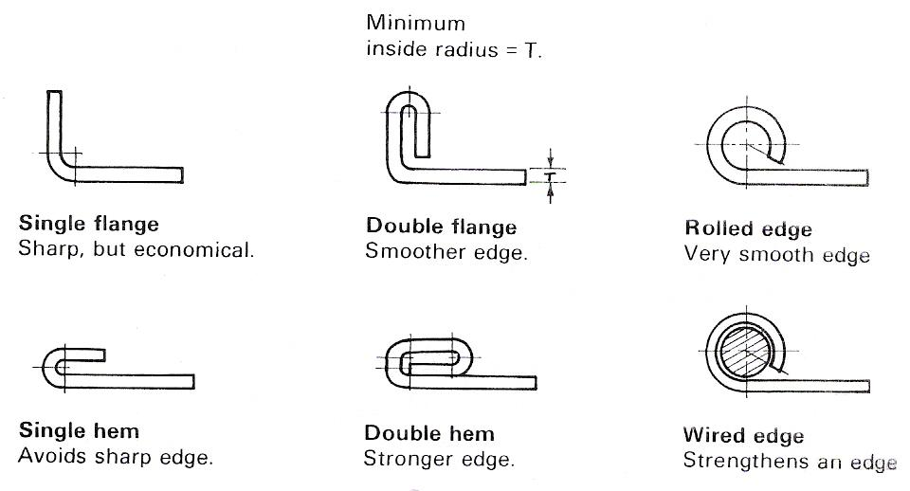
Figure 1 - Types of Commonly Used Bonds in Sheet Metalworking

Rivets

Riveting
Riveting is an economic and permanent way of joining metals. The rivets are put into place and ten the second head is formed by a machine. This pressure also compresses the body sides of the rivet pushing it against the sides of the hole. Small rivets may be set manually.
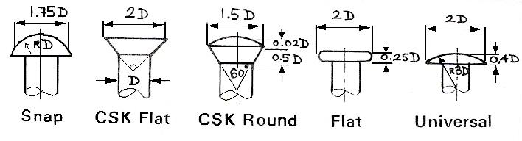
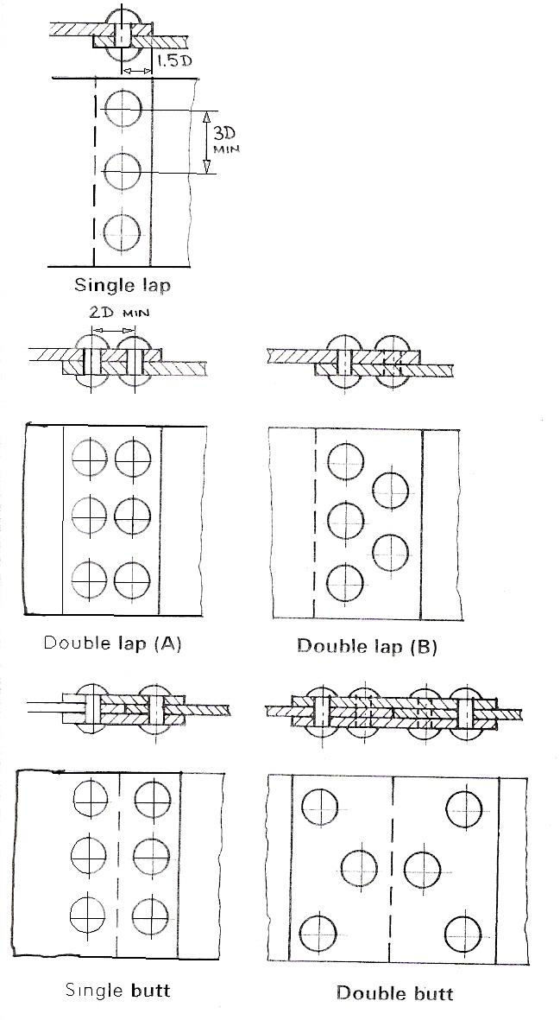
Figure 2 – Rivet Head Types

Pop Riveting Guns
“Pop” Riveting Guns are used extensively with “pop” rivets for the assembly of light fabrications and are particularly useful for the assembly of ductwork where access is restricted to one side of the work only. There are three different types available: hand “pop” gun, lazy tongs and pneumatic (air).

Hand “Pop” Gun
Riveting in confined spaces requires the use of a hand “pop” gun. These are unsuitable for larger dimensions of rivets, due to the reduced amount of leverage available.
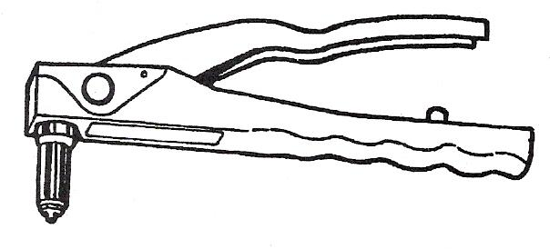
Figure 3 - Hand "Pop" Gun

Lazy Tongs
Lazy tongs are used for the larger diameters of rivets, where sufficient working space is available to permit operation of the tool.
The construction of the tool permits a moderate pressure on the handle to provide a strong pulling force on the rivet mandrel.
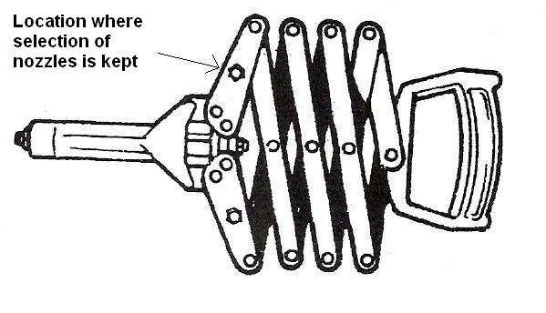
Figure 4 - Lazy Tongs

Type of Pop Rivets
They come in a variety of sizes and all guns come with a selection of interchangeable nozzles to suit rivet size.
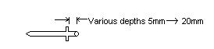
Figure 5 - Standard Rivet

Clamping and Fixed Stops

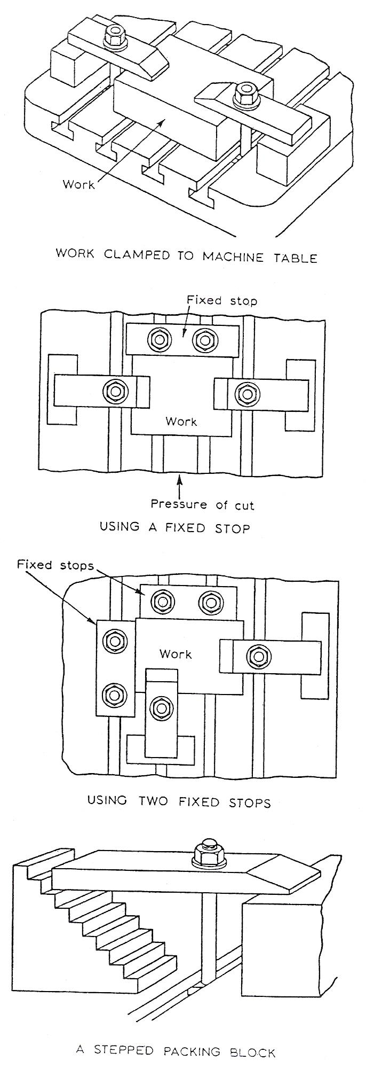
Clamping of Work
When machine tools are used, the work is frequently held in a machine vice this is bolted to the machine table. Because of the size or shape of some· work it cannot be held in a vice but must be clamped to a machine table or faceplate.

Clamps
The top illustration shows how clamps are used to prevent movement of the work during machining.
The height of the packing should be the same as the height of the work, with the bolt nearer the work than the packing.
This method of clamping causes a downward pressure to be applied which forces the work against the machine table. It is suitable when the cutting pressure is not too great but if heavy cutting forces are to be applied a fixed stop may be used.

Fixed Stops
A fixed stop will help to prevent movement of the work when heavy cutting pressures are applied. Care should always be taken to ensure that the stop is placed in such a position that it opposes the cutting force.
Two fixed stops; positioned as shown, will oppose cutting forces in two directions; they will also locate the job, which saves time when on production work.

Never
Over tighten clamping bolts - it could lead to distortion of the machine table or the work.

Always
Ensure that the bolts are long enough to allow for the full thread of the nut to be used.

Holding the Work for Drilling
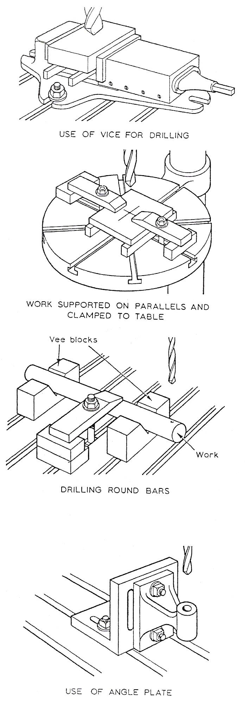
Never hold the work by hand when drilling. Jamming of the drill could cause the work to fly around and cause serious injury.

The Machine Vice
This is a quick and convenient method of holding work for drilling. Parallels should be placed under the work to prevent damage to the vice when the drill breaks through.

Clamping of Work
Larger work may be held by clamping directly to the machine table or supported on parallels and clamped. If work is not supported on parallels take care that the drill does not damage the machine table.

Use of Vee Blocks
Cylindrical work can be supported on one or more vee blocks and clamped as shown. Ensure that work is well supported at the point to be drilled.

Use of Angle Plate
It is sometimes necessary to clamp a job against an angle plate to ensure accurate drilling. The surface that is in contact with the angle plate is usually one which has been previously machined. G clamps, bolts or clamps may be used to hold work against the angle plate.

Always
Make sure that the work is well supported before commencing drilling.

Never
Trust makeshift work-holding arrangements because they may result in damage to the cutting tool or personal injury.

Edge Distance/Pitch

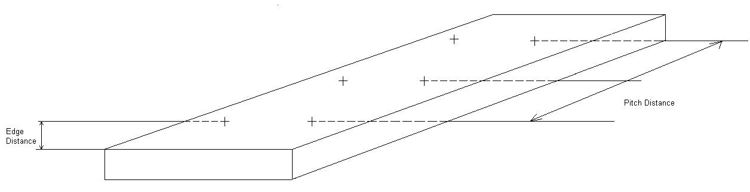
Figure 6 - Edge Distance / Pitch

Working Clearance
In all bolted or riveted connections sufficient clearance must be provided to allow for turning of a bolt-head or nut with a spanner, or driving a rivet with a rivet set or 'dolly'.

Applications – Types of Rivet and Rivet Head
The solid rivet has been in use for many hundreds of years. Today rivets in general use are made from SOFT IRON, MILD STEEL, COPPER, BRASS, ALUMINIUM and a range of ALUMINIUM ALLOYS.
The standard types of rivet heads are illustrated in Figure 7 together with the method employed when countersunk rivets are used for joining thin material to thick material.
Tinners and flat head rivets are used in most general sheet metal fabrications, where the metal is very thin and little strength is required. The countersunk head is used when a flush surface is required, and the roundhead or snaphead is most widely used where the joint must be as strong as possible. Mushroom head or 'knobbled rivets' as they are termed in the steel construction industry, are used where it is necessary to curtail the height of the rivet head above the metal surface, as, for example, on the outer fuselage 'skins' of aircraft in order to decrease 'drag', or in the case of steel chutes and bunkers, to reduce obstruction on the inside surfaces. Pan head rivets are very strong, and are, therefore, widely used for girders and heavy constructional engineering.
'Tinners' are similar to flat head rivets. They are made of soft iron and are usually coated with tin to prevent corrosion and to make them easier to soft solder - hence their name 'tinners'.
Always use the correct rivet for a particular metal to be riveted. When riveting aluminium, for example, use aluminium rivets; and when riveting copper use copper rivets.
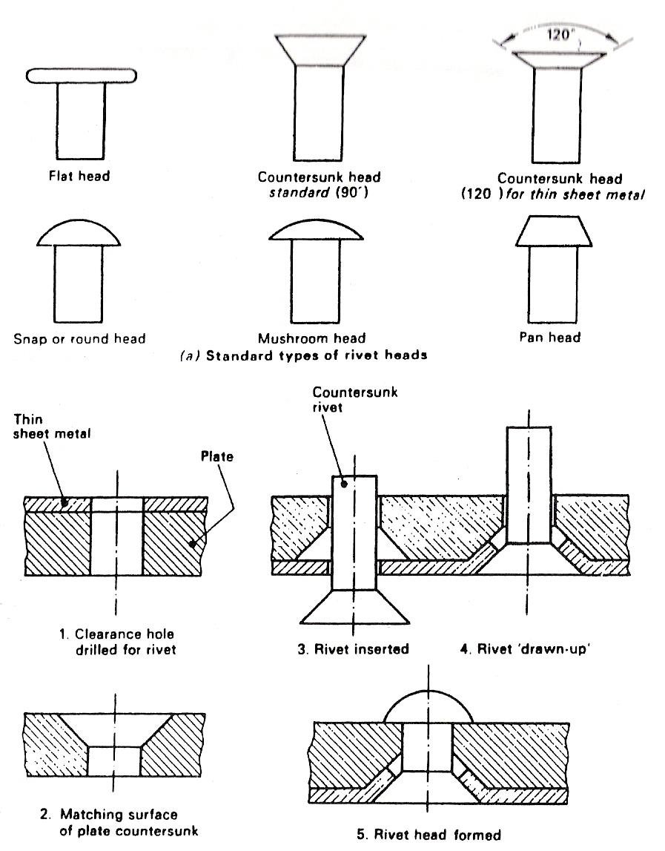
Figure 7 - Rivet Heads and Applications

Applications – Pop Riveting
Pop rivets, unlike solid rivets, are tubular and therefore much lighter in weight. They are manufactured from either aluminium alloy for lightness or nickel alloy for additional strength and corrosion resistance. They were originally designed for blind or one-sided riveting, by which rivets can be set in places otherwise inaccessible. Only one operator is required, the rivets being set or clinched with the aid of special handheld 'lazy tongs' or pliers. Although their main application has been in aircraft construction and motor vehicle body building, where frequently it is necessary to join thin material to thicker supporting members and lightness is important, they are often used in place of solid rivets for general riveting. They are available in diameters 2.4 mm, 3.2 mm, 4 mm and 4.8 mm for joining thicknesses up to 12.7 mm. With regard to speed of application, on a reasonably straight run it is possible to set pop rivets at a rate of twenty rivets per minute. Figure 8 illustrates the setting of pop rivets.
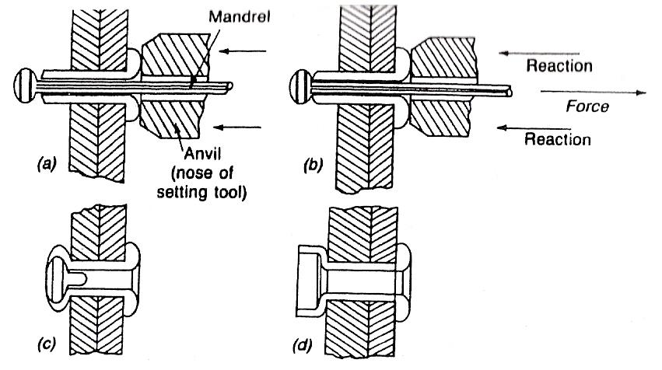
Figure 8 - Pop Rivets

Pop rivets are supplied with either a 'break-stem' or a 'break-head' type of mandrel to enable them to be set. Setting is carried out with the aid of specially designed hand tools, into which the mandrel with the rivet is inserted, so that the rivet head rests against an anvil. The rivet is pushed into the hole previously punched or drilled in the structure or fabrication to be riveted, and the tool operated (Figure 8(a)). Ideally the rivet hole should give approximately 0.102 mm clearance; see Table 2; however, this can be exceeded and a satisfactory joint still achieved.
Forward pressure is exerted on the rivet and simultaneously the mandrel is positively gripped and pulled in the opposite direction (Figure 8(b)). This action shortens and thickens the projecting end of the rivet, at the same time bulging the rivet and drawing the two sheets together. The tractive force breaks the mandrel, and its stem automatically ejects from the tool.

Break-Head Type
The mandrel is designed with a flat or cheese type head, so that the rivet is set as if it were 'snapped' between two sets as a solid rivet. The breaking point is immediately beneath the head of the mandrel - hence its name. On completion of the rivet setting, the mandrel head breaks off at its designed load (135 N to 360 N, according to the size of the rivet used).

Break-Stem Type
The head on this mandrel is very similar to that on the break-head type, but its stem breaks approximately 1.3 mm from the shoulder of its head.
Break stem pop rivets are used when it is necessary to retain the head, and therefore are ideally suitable when riveting is carried out on a totally enclosed member.
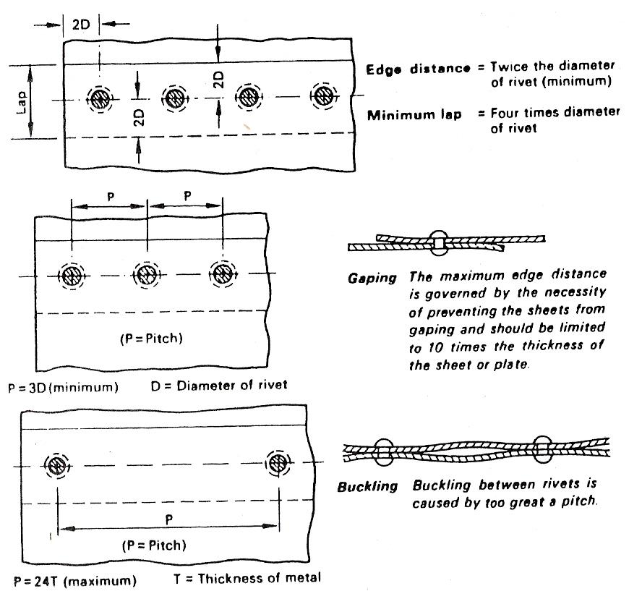
Figure 9 - Rivet Spacings
When making connections which require the use of rivets or bolts, the following are a few of the basic details which should be considered in order that many common defects may be prevented:
- When marking out use the correct allowance for edge clearance and pitch;
- All drilled or punched holes should be made to the correct clearance size to suit the bolt or rivet diameter, or as specified on the drawing;
- Remove any 'burrs' from around the edges of all holes before final assembly of the parts to be joined;
- Ensure that holes are correctly lined and matched before inserting the bolt or rivet;
- Use the proper type of rivet or bolt as specified on the drawing;
- Use rivets or bolts of the correct length;

Cause of Riveting Defect | Resultant Effect
Insufficient hole clearance | Rivet not completely ‘drawn through’. Not enough shank protruding to form head.  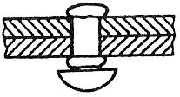  Original head of rivet ‘stands proud’, the formed head is weak and misshapen.
Hole too large for rivet | Hole not filled.  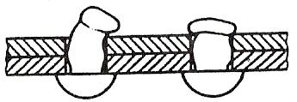  Rivet tends to bend and deform. Head weak and poorly shaped.
Rivet too short | Not enough shank protruding to produce a correctly shaped head.  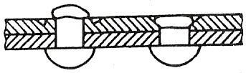  Plate surface damaged.  Countersinking not completely filled.
Drilling burrs not removed | Not enough shank protruding to form the correct size head.  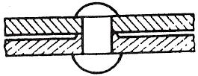  Plates or sheets not closed together. Unequal heads.
Sheets not closed together – rivet not drawn up sufficiently | Weak joint.  Rivet shank swells between the plates.  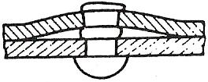  Not enough shank protruding to form correctly shaped head.
Rivet holes not matched | Weak misshapen head.  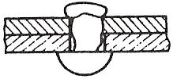  Rivet deformed and does not completely fill the hole.
Table 1 - Common Defects in Riveting
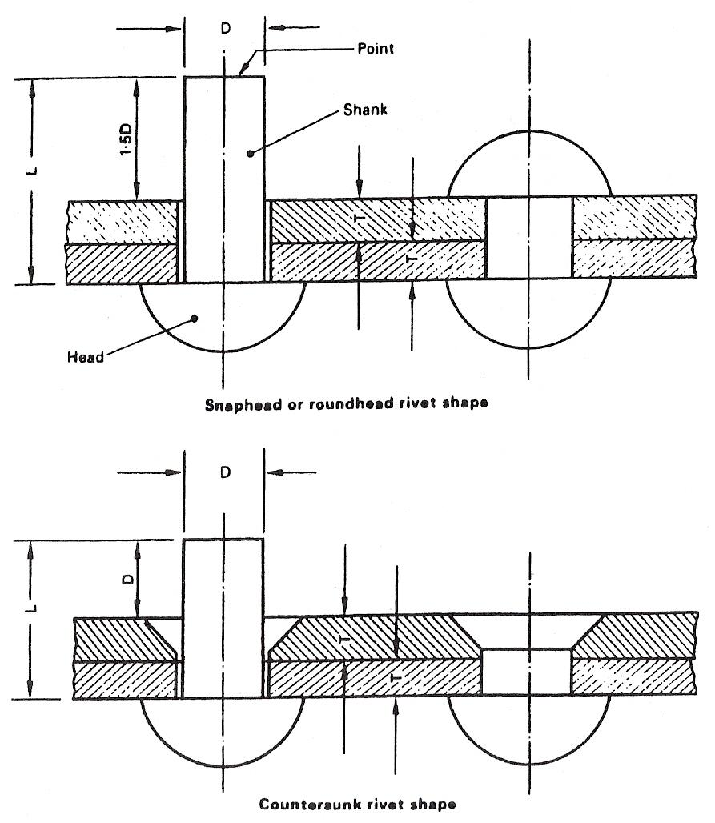
Figure 10 - Factors Influencing Choice of Rivet Lengths

Example:
What length of 9.5 mm diameter rivet is required to form a countersunk head and join two pieces of 4.76 mm plate?
Solution: L = T + T + D
= 4.76 + 4.76 + 9.5 mm
= 19.02 mm
Rivet length = 19 mm
Figure 10 illustrates both forms of rivet head.
Hole clearance is very important and should be kept to the absolute minimum. Table 2 shows the recommended hole clearances for various diameters of rivet.

Rivet Diameter (mm) | Hole Diameter (mm)
1.59 | 1.63
2.38 | 2.43
3.18 | 3.25
3.97 | 4.03
4.76 | 4.85
5.56 | 5.61
6.35 | 6.52
7.94 | 8.02
9.53 | 9.80
11.11 | 11.40
12.70 | 13.10
Table 2 - Recommended Diameters of Clearance Holes for Rivets

Rivet Spacing
Rivet holes should be spaced according to the specification of the job.
The space or distance from the edge of the metal to the centre of any rivet should be at least twice the diameter of the rivet, to prevent the rivets from tearing out.
A useful rule is to make the edge distance equal to 1½ diameters plus 9.5 mm. The maximum distance from the edge is governed by the necessity of preventing the sheets from 'gaping' and should be limited to 10 times the thickness of the sheet metal or plate.
The minimum distance between rivets (known as the 'pitch') should be sufficient to allow the rivets to be driven without interference or about three times the rivet diameter.
The maximum distance between rivets should never be such that the material is allowed to buckle between the rivets and in practice should never exceed 24 times the thickness of the sheet. Rivet spacing is illustrated in Figure 9.

Defects in Riveted and Bolted Joints
Most of the faults or defects associated with riveted and bolted connections are caused by bad workmanship. Numerous defects may be avoided by adopting an intelligent approach to the job in hand, especially in the preparation stage, and by careful use of tools.

Self Assessment

Questions on Background Notes – Module 1.Unit 13

No Suggested Questions and Answers.

Index

A
Applications – Pop Riveting, 16
Break-Head Type, 17
Break-Stem Type, 17
Applications – Types of Rivet and Rivet Head, 14
C
Clamping and Fixed Stops, 11
Always, 11
Clamping of Work, 11
Clamps, 11
Fixed Stops, 11
Never, 11
D
Defects in Riveted and Bolted Joints, 21
E
Edge Distance/Pitch, 13
H
Hand “Pop” Gun, 10
Holding the Work for Drilling, 12
Always, 12
Clamping of Work, 12
Never, 12
The Machine Vice, 12
Use of Angle Plate, 12
Use of Vee Blocks, 12
L
Lazy Tongs, 10
M
Making Sharp Edges Safe, 8
P
Pop Riveting Guns, 10
R
Rivet Spacing, 21
Rivets, 9
Riveting, 9
T
Type of Pop Rivets, 10
W
Working Clearance, 14

